**Big Data Capstone Project : Health care Data Analysis**

**Project Flow:**

1. **Prescriber_report_capstone_project:**

**Data Ingestion:**

**step1:** Sample data files are provided and they have to be ingested in to HDFS in to the project’s location

**hdfs dfs -mkdir -p prescpipeline/staging/prescriber**

**hdfs dfs -put USA_Presc_Medicare_Data_12021.csv prescpipeline/staging/prescriber**

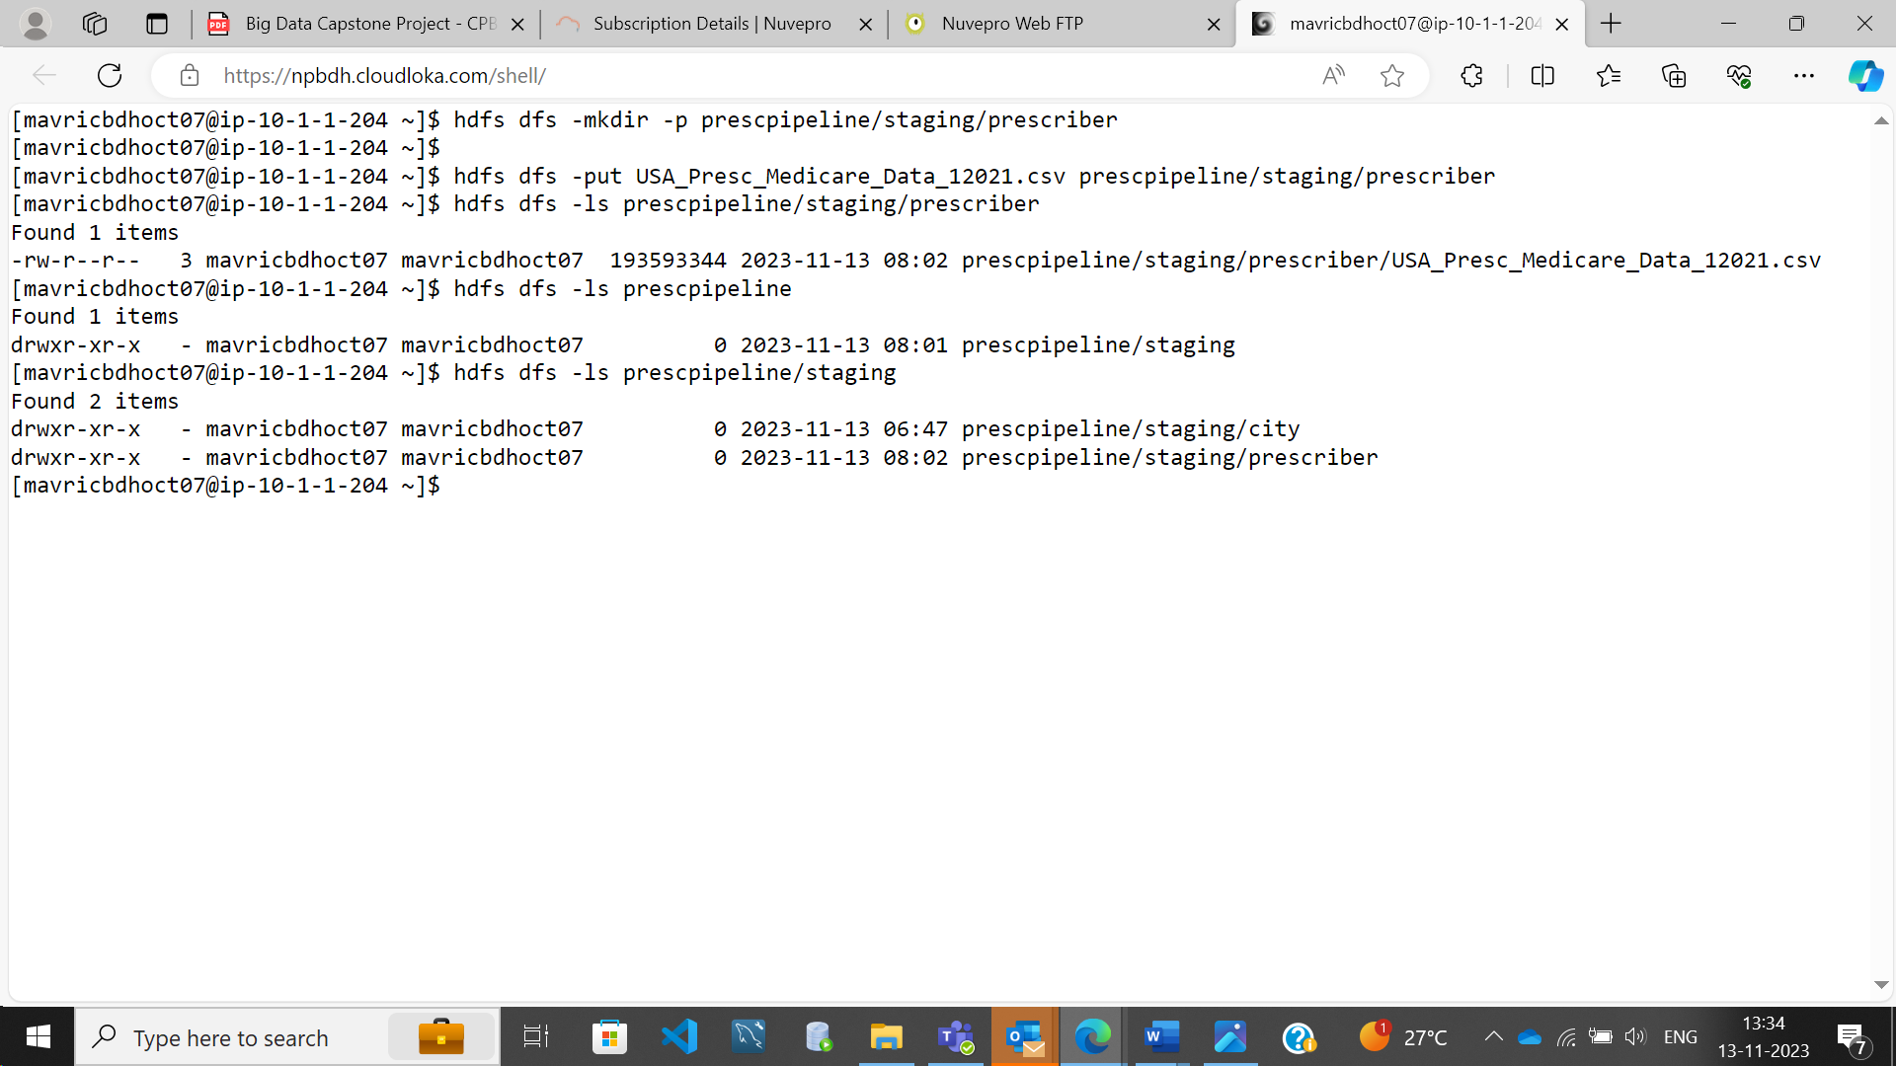

**prescriberDF=spark.read.option("header",True).option("inferschema",True).csv("prescpipeline/staging/prescriber/USA_Presc_Medicare_Data_12021.csv")**

**prescriberDF.show(10)**

**prescriberDF.printSchema()**

**prescriberDF.count()**

**Data Cleansing/Preprocessing:**

**Selecting the required columns**

**PrescriberDF1=prescriberDF.select('npi','nppes_provider_last_org_name','nppes_provider_first_name','nppes_provider_city','nppes_provider_state','specialty_description','drug_name','total_claim_count','total_day_supply','total_drug_cost')**

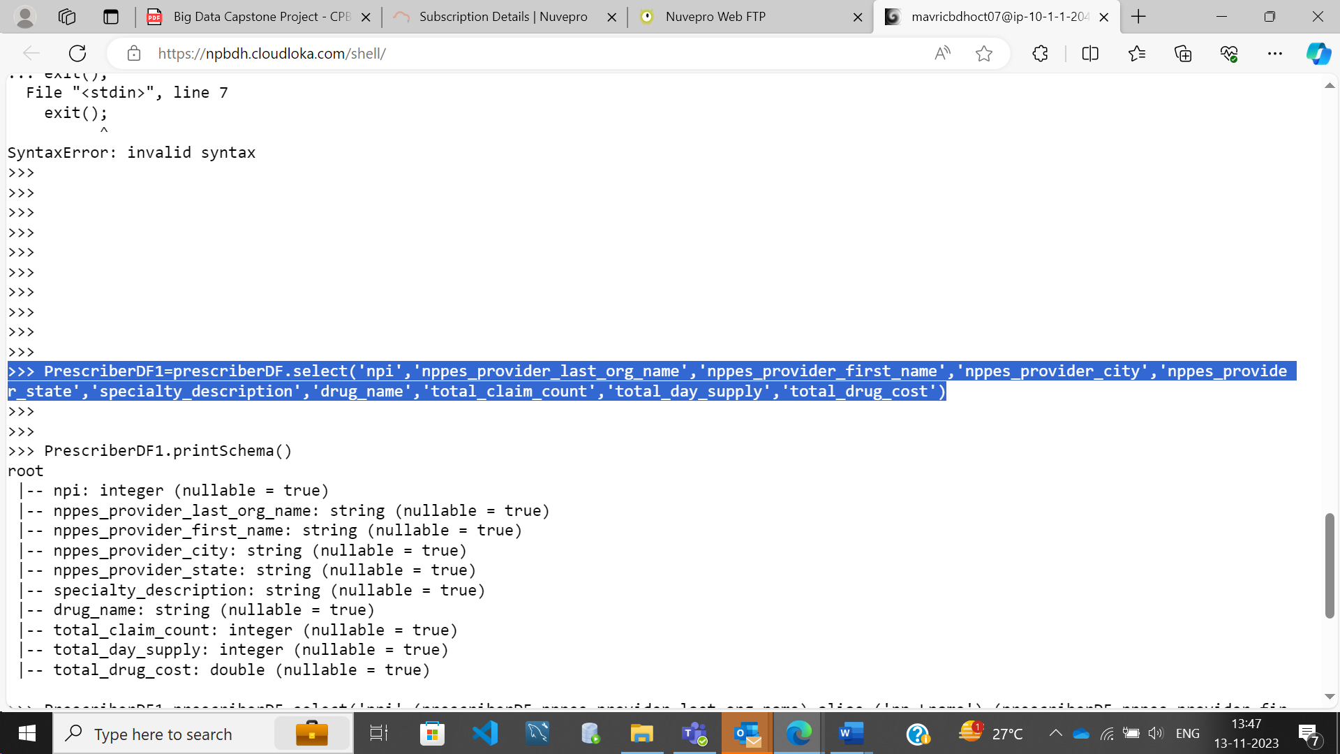

**Rename the above fields to shorter names**

**PrescriberDF1=prescriberDF.select('npi',(prescriberDF.nppes_provider_last_org_name).alias ('np_Lname'),(prescriberDF.nppes_provider_first_name).alias ('np_Fname'),(prescriberDF.nppes_provider_city).alias('np_city'),(prescriberDF.nppes_provider_state).alias('np_state'),(prescriberDF.specialty_description).alias ('speciality_desc'),(prescriberDF.drug_name).alias ('drug_nm'),(prescriberDF.total_claim_count).alias('tot_clm_count'),(prescriberDF.total_day_supply).alias ('tot_day_supp'),(prescriberDF.total_drug_cost) .alias ('tot_drug_cst'))**

**Add a Country Field 'USA' to the above data**

**from pyspark.sql.functions import col, lit**

**PrescriberDF1=PrescriberDF1.withColumn("Country", lit("USA"))**

**PrescriberDF1.show(3)**

**Clean the “years_of_exp” to extract only the numbers.**

(Hint : use regexp_extract from the package pyspark.sql.functions)

**Adding years of exp Column to PrescriberDF1:**

**PrescriberDF1=prescriberDF.select('npi',(prescriberDF.nppes_provider_last_org_name).alias ('np_Lname'),(prescriberDF.nppes_provider_first_name).alias ('np_Fname'),(prescriberDF.nppes_provider_city).alias('np_city'),(prescriberDF.nppes_provider_state).alias('np_state'),(prescriberDF.specialty_description).alias ('speciality_desc'),(prescriberDF.drug_name).alias ('drug_nm'), (prescriberDF.total_claim_count).alias('tot_clm_count'),(prescriberDF.total_day_supply).alias ('tot_day_supp'),(prescriberDF.total_drug_cost) .alias ('tot_drug_cst'),'years_of_exp')**

**Removing special Characters from years of exp column:**

**import pyspark.sql.functions as F**

**PrescriberDF1= PrescriberDF1.withColumn("years_of_exp", F.regexp_replace("years_of_exp", "= ", ""))**

**PrescriberDF1.show(10)**

**Convert the years_of_exp field to integer**

**from pyspark.sql.functions import concat, concat_ws,col, lit**

PrescriberDF2 = PrescriberDF1.withColumn("years_of_exp",col("years_of_exp").cast("int"))

PrescriberDF1.show()

**Combine First Name and Last Name in to a single field and remove the individual columns**

**Combining columns:**

**from pyspark.sql.functions import concat, concat_ws,col, lit**

**PrescriberDF2 = PrescriberDF1.withColumn("presc_fullname",concat_ws(" ", "np_Fname", "np_Lname"))**

**PrescriberDF1.show(3)**

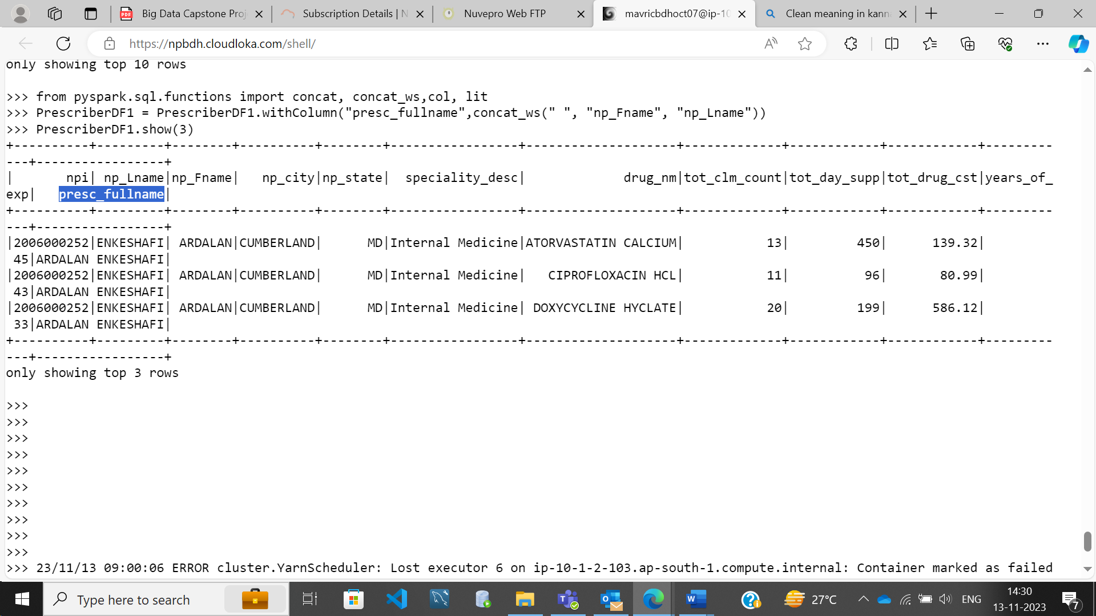

**Removing individual columns**

**PrescriberDF1 = PrescriberDF1.drop("np_Fname", "np_Lname")**

**PrescriberDF1.show(3)**

**Count the number of null values for each column**

**from pyspark.sql.functions import col,isnan, when, count**

**PrescriberDF1=PrescriberDF1.select([count(F.when(isnan(c) | col(c).isNull(),c)).alias(c) for c in PrescriberDF1.columns]).show()**

**Clean all the Null/Nan Values**

**[Delete the records where the PRESC_ID and DRUG_NAME is fields are NULL. Use dropna() of dataframe]**

**PrescriberDF2 = PrescriberDF1.na.drop(subset=["npi"])**

**PrescriberDF2 = PrescriberDF1.na.drop(subset=["drug_nm"])**

**PrescriberDF2.printSchema()**

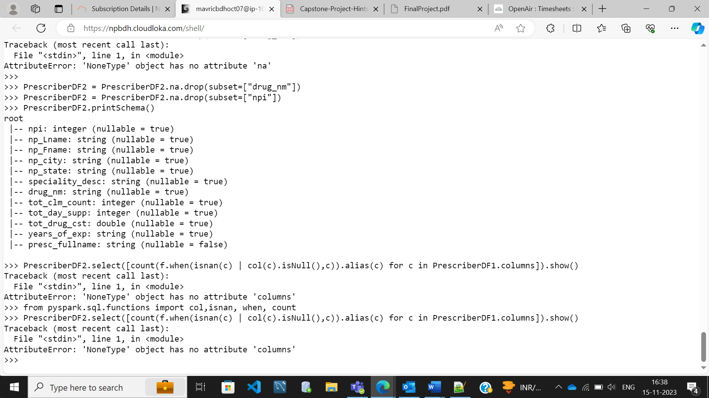

**PrescriberDF2.select([count(f.when(isnan(c) | col(c).isNull(),c)).alias(c) for c in PrescriberDF2.columns]).show()**

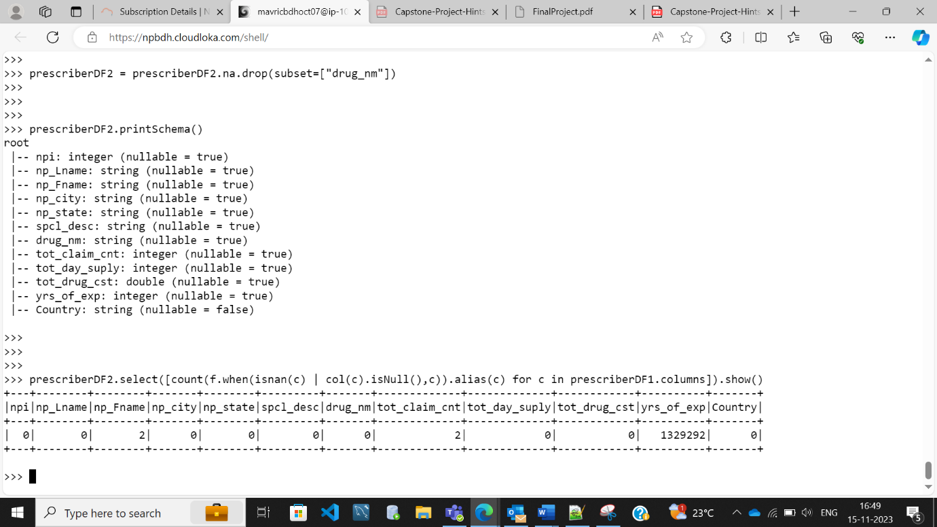

**Transformations:**

**Step 1 :Transformation**

**Transform logic: Prescriber Report:**

Top 5 Prescribers with highest total_claim_count per each state.

Consider the prescribers only from 20 to 50 years of experience.

from pyspark.sql import functions as F

PrescriberDF2 = PrescriberDF2.filter(F.col("yearrs_of_exp").between(20,50))

PrescriberDF2.createOrReplaceTempView("prescriber")

spark.sql("SELECT min(yearrs_of_exp) , max(yearrs_of_exp) from prescriber").show()

spark.sql("SELECT npi as Prescriber_ID , np_Fname as Prescriber_Full_Name, np_state as Prescriber_State, tot_clm_count as Total_claim_count, tot_day_supp as Total_Days_Supply, tot_drug_cst as Total_Drug_Cost from prescriber where tot_claim_cnt_rank<= 5").show()

****Run in HDFS***

hdfs dfs -mkdir -p prescpipeline/output/prescriber

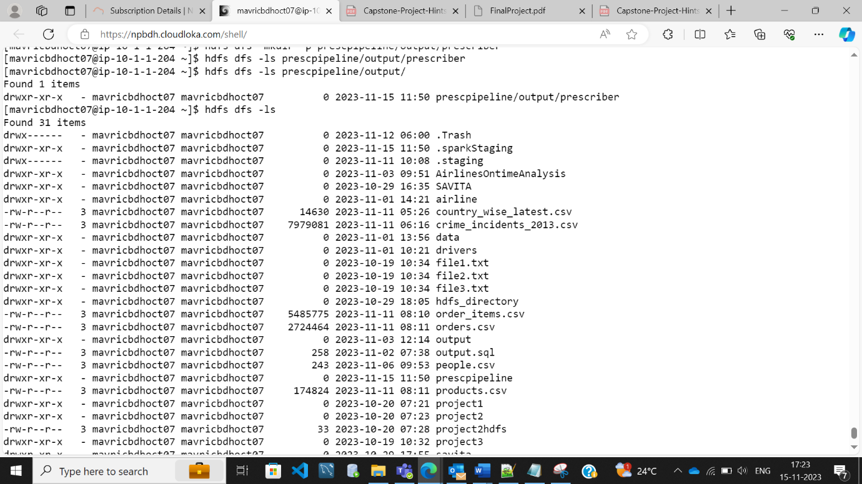

**Writing the output into HDFS in ORC format and snappy compression :**

from pyspark.sql import SparkSession

spark=SparkSession.builder.appName("SparkHive").enableHiveSupport().config("spark.sql.warehouse.dir","/user/hive/warehouse").getOrCreate()

spark.sparkContext.setLogLevel("ERROR")

prescriber_report_DF.write.mode("overwrite").option("compression","snappy").orc("/user/mavricbdhoct07/prescpipeline/output/prescriber/prescriber_report.orc")

**checking the output report file generated in hdfs:**

hdfs dfs -ls /user/mavericbdhoct07/prescpipeline/output/prescriber/prescriber_report.orc/



prescriber_report_DF.write.partitionBy("tot_clm_count").mode("overwrite").saveAsTable("savitadb. prescriber_report_DF ")

use savitadb;;

show tables;

select * from prescriber_report_DF order by Total_claim_count desc ;

